


AB Bank Zambia

Monthly Report
March 2026

Contents
1. Executive Summary 2
1.1. Key Highlights: 2
1.1.1. Incident Volume & Trends: 2
1.1.2. Detection & Response Performance: 2
1.2. Incident Trends & Analysis: 3
1.3. High-Severity Incidents: 4
2. March Alerts & Incidents Overview 4
2.1. Overall Volume 4
2.2. Incidents Processing 5
2.3. Mean Time To Detect (MTTD) 5
3. Incidents Highlights 6
3.1. Top Incidents by type 6
3.2. Analysis of Key Incident Trends 7
3.3. High Severity 9
4. Cybersecurity Trends and Threats – Zambia(March, 2026) 9
4.1. Key Threats and Incidents 10
4.2. Regional Spillover and Infrastructure Risks 11
4.3. Government and Infrastructure Response 11
5. Conclusion and Recommendations 12
5.1. Recommendations 12
5.2. Conclusion 13

Executive Summary
This security report provides an in-depth analysis of security incidents, alerts, and operational activities managed by TeKnowledge for AB Bank Zambia during the reporting period (March 2026). The findings highlight key security trends, detection and response performance, and proactive measures taken to enhance the organization’s security posture.

Key Highlights:

Incident Volume & Trends:
A total of 823 security incidents were generated in the Production environment and 0 Security incidents in the Test Environment. All incidents were processed in Microsoft Sentinel, encompassing both manually investigated cases and automated detections.
The most prevalent security events still include Authentication Attempt - Default Account, User Account Modified, Incidents Summary Alert, FortiGate Successful Login and Source Stopped Sending Data: Syslog highlighting the performance of the Security Environment on Administrative account login and User-Account Management in the Security environment, Notification of Change and Log Monitor Status.

Detection & Response Performance:
Mean Time to Detect (MTTD): 2 minutes and 53 seconds, ensuring timely identification of incidents.
Additionally, the breakdown of MTTD by severity is as follows:
High Severity: 2 minute and 29 seconds
Medium Severity: 2 minutes and 47 seconds
Low Severity: 2 minutes and 4 seconds
Informational: 2 minutes and 53 seconds

Average time to First Response: The average Time to First Response was 5 minutes. See the screenshot below for the breakdown according to the incidents’ severity.
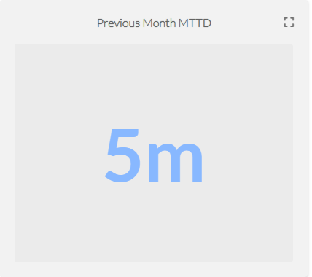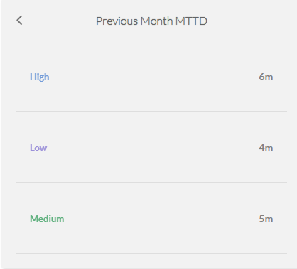
Mean Time to Resolution (MTTR): The average Mean Time to Resolution (MTTR) for this reporting period was 20 minutes. The screenshot below provides a detailed breakdown by severity.
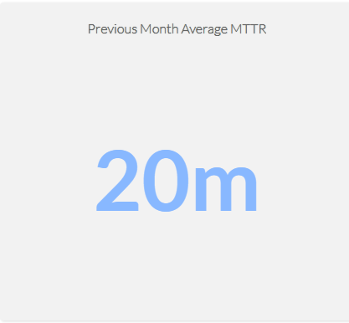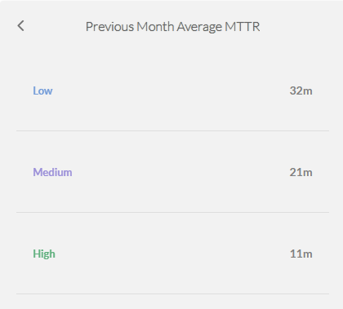

Incident Trends & Analysis:
The top recurring incident types identified in March accounted for 610 of the total incidents. These incidents were mainly tied to Authentication Attempt - Default Account, User Account Modified, Incidents Summary Alert, FortiGate Successful Login and Source Stopped Sending Data: Syslog indicating Administrative Account Authentication Notifications, Access-Notification to VPN, Users-Account Management Notification and Log-Server Operational Status.
The most frequent alerts were related to:
- Authentication Attempt - Default Account – 350
- User Account Modified – 97
- Incidents Summary Alert – 59
- FortiGate Successful Login – 58
- Source Stopped Sending Data: Syslog - 46
All these incidents were thoroughly reviewed and escalated where necessary, helping to maintain Operational stability and security to the critical Assets.

High-Severity Incidents:
A total of 27 alerts were categorized as high severity, which entails Non Domain Controller Active Directory Replication. The high-severity case confirmed to be carried out by The Dedicated Service-Account for Active Directory Replication.

March Alerts & Incidents Overview

Overall Volume
In the month of March, a total of 823 incidents from production environment were handled on MS Sentinel. Further breakdown in severity showed that 27 were of High Severity, 722 were of Medium Severity, 15 were of Low Severity and 59 Informational Incidents. This volume includes manually-processed incidents and automatically-addressed incidents: through pre-configured automation protocols.
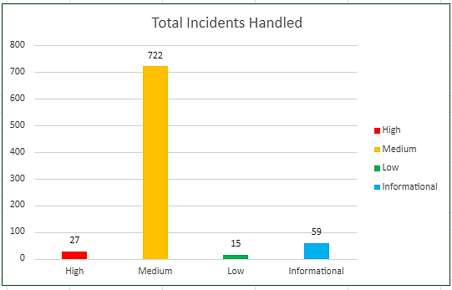

Incidents Processing
During the reporting period, TeKnowledge successfully monitored, detected, and responded to a total of 823 security incidents within the AB Bank Zambia production environment. The SOC team processed all incidents, ensuring a comprehensive approach to threat detection and response.

Mean Time To Detect (MTTD)
The average Mean Time to Detect (MTTD) for this reporting period was 2 minutes and 53 seconds. Average detection time for High-severity was 2 minute 29 seconds, Medium-severity was 2 minutes 47 seconds, Low-severity was 2 minutes 4 seconds, and Informational incidents were averagely detected at 4 minutes 22 seconds
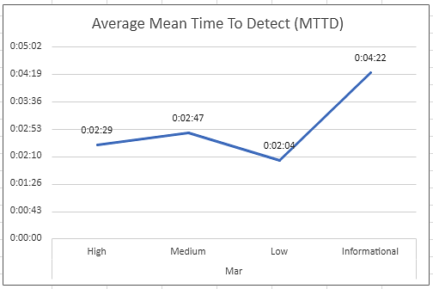

Incidents Highlights

Top Incidents by type
During the reporting period, TeKnowledge monitored security incidents, identifying the most prevalent issues within your environment. Below is a breakdown of the top incident types detected:

Incident Title | Count of Title
Authentication Attempt - Default Account | 350
User Account Modified | 97
Incident Summary Alert | 59
FortiGate Successful Login | 58
Source Stopped Sending Data: Syslog | 46
FortiGate Logon Failure | 30
Non Domain Controller Active Directory Replication | 29
FortiGate UTM Alerts | 27
User Added to Critical Group | 23
User Account Created/Enabled | 21
Grand Total | 740

Analysis of Key Incident Trends
During this reporting period, TeKnowledge identified and categorized multiple security incidents within the AB Bank Zambia production environment. The breakdown below highlights key trends, notable threat patterns, and actionable recommendations to improve detection and response capabilities
- Authentication Attempt-Default Account (350 Incidents)
Description: This rule monitors authentication attempts using default accounts like "Administrator," "Root," or "Guest." It searches for specific logon event types (4624, 4625, 4768, 4771, 4648, 4801) and checks if the account being used is one of the default names.
Observations: These incidents were confirmed to be generated by legitimate service accounts dedicated to specific service in the environment.
- User Account Modified (97 Incidents)
Description: This rule detects modifications made to user accounts in Active Directory by monitoring Event ID 4738. It focuses on changes to user account attributes and identifies the account and subject responsible for the modification
Observation: These User account modifications were confirmed to be carried out by authorized IT Systems Administrators.
- Incident Summary Alert (59 Incidents)
Description: This rule produces a summary count of incidents generated in the past 12hrs.
- FortiGate Successful Login (58 Incidents)
Description: This rule detects successful logins to FortiGate's management console by parsing the Syslog messages and extracting login details like user, source IP, and destination IP.
Observation: All the VPN connections were confirmed to be from legitimate and authorized users.
- Source Stopped Sending Data: Syslog (46 Incidents)
Description: This rule monitors the Syslog table for data flow and triggers an alert if the number of Syslog records drops below 1,000, indicating a potential data loss from the source.
Review: These incidents were escalated to the Network Team
- FortiGate Logon Failure (30 Incidents)
Description: This rule detects failed login attempts on FortiGate devices' administrative interface. It parses the Syslog messages for failure events, while excluding specific benign scenarios.
Observation: These were triggered from legitimate users who made mistakes in the login password and/or ssh error due to expired token.
- Non Domain Controller Active Directory Replication (29 Incidents)
Description: This query detects potential attempts by non-computer accounts (non domain controllers) to retrieve/synchronize an active directory object leveraging directory replication services (DRS). A Domain Controller (computer account) would usually be performing these actions in a domain environment. Another detection rule can be created to cover domain controllers accounts doing at rare times. A domain user with privileged permissions to use directory replication services is rare.
Observation: The Domain controller Replication activities were confirmed to be scheduled task assigned to dedicated service-account
- FortiGate UTM Alerts (27 Incidents)
Description: This rule detects FortiGate Unified Threat Management (UTM) alerts by parsing Syslog messages that contain UTM alert indicators and identifying relevant details like source and destination IPs.
Feedback: The review of all the incidents shows that all the malicious requests came from “ZGrab Scanner” and ‘Masscan.Scanner”; all the requests were identified as malicious and dropped by the firewall.
- User Added to Critical Group (23 Incidents)
Description: This rule detects when a user account is added to critical security groups in Active Directory by monitoring specific Event IDs (4756,4728 and 4732). It identifies the user being added and the target group to which they are added.
Feedback: The additions to critical Group was confirmed to be done by authorized IT Administrators

- User Account Created/Enabled (21 Incidents)
Description: This rule detects the creation or enabling of user accounts in Active Directory by monitoring for Event IDs 4720 and 4722. It logs details about the subject user and the target account being created or enabled.
Observation: The User Account management activity, which entails creation, enable and disable was confirmed to be carried out by Authorized IT Administrators.

High Severity
During the reporting period, 27 high-severity incidents were recorded.
Incident Title | Count of Title
Non Domain Controller Active Directory Replication | 27
Grand Total | 27

- Non Domain Controller Active Directory Replication (27 Incidents)
Review: This rule detects potential attempts by non-computer accounts (non domain controllers) to retrieve/synchronize an active directory object leveraging directory replication services (DRS). A Domain Controller (computer account) would usually be performing these actions in a domain environment.
On further investigation, it was discovered that this was an authorized activity of a dedicated Service-Account for Azure AD Connect synchronization.

Cybersecurity Trends and Threats – Zambia (March, 2026)
In March 2026, Zambia's cyber-risk picture was shaped less by publicly disclosed enterprise breaches and more by high- impact social engineering, manipulated digital content, and resilience risks in critical digital service platforms. The clearest March signals were the continued weaponization of fake/manipulated images and Al-assisted content, a court- tracked cyber fraud case tied to false Facebook content, and a technical outage affecting Zambia Revenue Authority core tax and customs systems. At the same time, public-sector messaging in March shows growing concern about digital literacy, online safety, and cyber awareness as Zambia's digital transformation expands.

Key Threats and Incidents
Manipulated and Al-assisted digital content as a live threat vector
On March 3, 2026, reporting in Zambia highlighted concern over the spread of fake images, videos, and voice notes, with warnings that manipulated content was causing harm and distress and could threaten the integrity of the 2026 General Elections. The reporting explicitly frames this as a misuse of Al and digitally altered media, and calls for enforcement under the Cyber Security and Cyber Crimes Act of 2025. This makes synthetic and manipulated content one of Zambia's clearest March cyber threat trends.
Computer-related misrepresentation and cyber fraud through Facebook content
A late-March Zambia Monitor report details a court case involving Mambwe Zimba, who was charged under Section 12(1) of the Cyber Crimes Act No. 4 of 2025 for allegedly transmitting a manipulated image through a Facebook page titled "Zambia for All 2026." According to the report, prosecutors argued the image was intended to be treated as authentic. This is important because it shows how false digital content is not just reputational noise but can become a prosecutable cyber-fraud issue when designed to deceive the public.
Critical digital service outage affecting tax and customs systems
On March 9, 2026, Lusaka Times reported that a technical failure on March 1 disrupted Zambia Revenue Authority's core tax and customs systems, including ASYCUDAWorld, TaxOnline, Smart Invoice, and the Integrated Payment System. The outage prevented payment processing, customs clearance, and tax-document submission until services were restored within 72 hours. Even without evidence of malicious intrusion, this is a significant cyber-relevant risk event because it highlights the fragility of critical digital public infrastructure and the downstream impact of service unavailability on businesses, trade, and government operations.
No widely confirmed public ransomware or major enterprise-breach disclosures in March
Within March 1-31, 2026, I did not find widely verified public reporting of Zambia-specific ransomware incidents or major enterprise data-breach disclosures. The visible March risk picture was instead dominated by misinformation/manipulated content, platform abuse, and service availability risk. That should be read as a public-disclosure gap, not proof that malicious activity was absent.

Regional Spillover and Infrastructure Risks
Election-linked information manipulation raises cyber risk beyond simple "fake news"
March reporting shows that digitally altered content in Zambia is being treated as a threat to social stability and election integrity. In practice, these campaigns can trigger panic, reputational damage, harassment, and coordinated abuse, and are often amplified through Facebook, WhatsApp, and short-form media channels. That makes Zambia vulnerable not only to local actors, but also to cross-border influence and disinformation playbooks that are cheap to execute and hard to contain.
Critical digital infrastructure outages create secondary fraud opportunities
The ZRA outage illustrates a broader operational risk: when citizens and businesses cannot reliably access official systems, attackers can exploit the confusion using fake support channels, spoofed notices, payment redirection, and impersonation scams. This is a common spill-over risk around service disruptions, especially where digital services are central to tax, customs, or payment workflows. This point is an inference based on the documented outage and the types of systems affected.
Youth-heavy digital expansion increases exposure to online abuse and unsafe behavior
SMART Zambia's March youth-engagement messaging stressed that digital literacy, responsible use, and online safety are essential as more young Zambians gain access to digital platforms and opportunities. That matters because broader access, without equivalent safety awareness, tends to increase exposure to fraud, grooming, impersonation, and social engineering.

Government and Infrastructure Response
Cyber law enforcement is becoming more visible in March cases
The March court reporting around manipulated Facebook content shows the Cyber Crimes Act No. 4 of 2025 being used in practice against alleged digital deception and computer-related misrepresentation. That is a notable enforcement signal: Zambia is moving from general cyber-law messaging to actual application in public cases.

Public warnings on Al misuse and harmful content
The March 3 Lusaka Times report shows public advocacy for ZICTA and law enforcement to crack down on abusive use of Al-generated or manipulated content. Whether or not every case is technically "Al-generated," the policy concern is clear: Zambia now sees synthetic media and inauthentic digital content as a frontline cyber issue.

Operational recovery and continuity response to public-system outages:
ZRA's response to the March 1 outage included restoring affected services within 72 hours and waiving penalties and interest for impacted taxpayers. From a cyber-resilience perspective, that signals at least some continuity planning and incident
response capability for critical revenue systems, though the outage also exposed the degree of dependence on digital public infrastructure.

Digital-literacy and cyber-awareness efforts expanding alongside digital transformation
SMART Zambia's March communications emphasized digital citizenship, online safety, and cybersecurity-related skills, including references to training pathways such as Cisco Networking Academy and broader digital transformation initiatives. This matters because Zambia's response posture is not only punitive; it is also trying to reduce risk through awareness and capability building.

Sources: Lusaka Times(March 3, 2026) , Lusaka Times (March 9, 2026), Zambia Monitor, SMART Zambia Institute, SMART Zambia

Conclusion and Recommendations

Recommendations
Optimize Analytic Rules: Standardize entity mapping (Account, Host, IP, Process, File Hash, URL/Domain) across analytic rules to improve auto-grouping, speed up triage, reduce noise from non-production systems, and enhance reporting accuracy.
Expand SSH Detection: Develop additional analytic rules to increase visibility into SSH-based connections and activities, ensuring comprehensive coverage of remote-access behaviour.
Ensure Agent Resilience: Configure all log-forwarding agents to start automatically after reboots and set service recovery options to restart on failure, preventing data gaps after maintenance or outages.
Detect Log Gaps: Setup an analytic rule that flags servers with missing or delayed log data, enabling quick identification and remediation of sources that stop sending events.
Correct “Heartbeat Missing” Rule Configuration: Update the Rule Period from 30 minutes to 6–12 hours to broaden detection coverage and configure Event Grouping to “Group all events into a single alert”.
Emphasis on WithSecure EDR Integration with Microsoft Sentinel: Integrating WithSecure EDR with Microsoft Sentinel is recommended to improve security visibility and efficiency. This integration centralizes endpoint and cloud workload security events into a single monitoring platform, enhancing situational awareness and event correlation. By unifying security data within Sentinel, organizations can streamline investigations, automate responses, and accelerate incident detection and remediation, ultimately strengthening overall threat response capabilities.

Conclusion
The March 2026 reporting period marked a significant step forward in the security operations of AB Bank Zambia, with TeKnowledge continuing to provide dedicated 24/7 monitoring, incident detection, and rapid response through the Microsoft Sentinel platform. A total of 823 alerts were processed a significant increase from the previous month reflecting the need for optimization of the analytical rules in the environment.
The most detected threats included Authentication Attempt - Default Account, User Account Modified, Incidents Summary Alert, FortiGate Successful Login and Source Stopped Sending Data: Syslog underscoring the need for sustained vigilance in identity/access management as well as operational status of critical assets.
TeKnowledge’s SOC demonstrated high operational efficiency, with the following key performance:
- Mean Time to Detect (MTTD): 2 minutes and 53 seconds
- Average Time to First Response: 5 minutes
- Average Mean Time to Resolution: 20 minutes

27 high-severity incidents were recorded during this period.
As we move forward, TeKnowledge remains dedicated to strengthening your organization’s defences through:
- Continuous monitoring, rapid threat detection and Incident escalation
- Strategic improvements to rule coverage and incident handling workflows

We appreciate the trust placed in TeKnowledge to safeguard AB Bank Zambia’s digital environment and look forward to our continued partnership in building a more secure and resilient infrastructure.

